Boilerplate

Purpose
- This is a “template” Incident Response Plan to be used as a “starting point” for the sake of helping you develop your Incident Response Process.

Copyright / Permission to Use
- Permission to use this document is conditional upon you receiving this template directly from an infotex employee, infotex website or e-commerce site, or an infotex workshop / training presentation.
- By using this template either in its entirety or any portion thereof, you acknowledge that you agree to the terms of use as dictated in the “Transfer of Copyright Agreement” located at copyright.infotex.com. This agreement establishes that when you customize this template to your specific needs, your organization may have copyright of the customized document. However, infotex retains copyright to the template. This agreement also establishes that you will not share this or any other template with third parties other than auditors and examiners. You may not transfer ownership of the customized documents to any other organization without the express written permission of infotex.

Instructions
- Make sure to read through the template carefully as not all situations will pertain to your organization. However, to assist you in customizing the document to your specific needs, we have attempted to color code areas that will need your special attention. Color coding is as follows:
  - All areas needing customization and/or consideration are in red.
  - Sections that are in brown are optional sections according to our definition of best practices. These sections may be removed if they do not match your needs.
  - Sections in blue are merely instructions or additional information for knowledge purposes and should be removed.
  - Sections in green are examples.
- Note that you should confirm that all text has been changed to “black” before considering this template final for your organization. If there are any sections in any other color than black, then all situations or customization has not been considered.
This section (Templates) may be removed once the document has been customized, for at that time we turn ownership of the customized document over to you.

© Copyright 2000 - 2013 infotex, Inc. All rights reserved.
NOTES ABOUT THIS DOCUMENT:
- The incident response plan enforces the board-level Incident Response Policy.
- This document should be used to train the IRT as well as a starting point during an incident. Usually incidents can cause a sense of urgency and often a state of paralysis. This plan should be pulled out to help center the team.
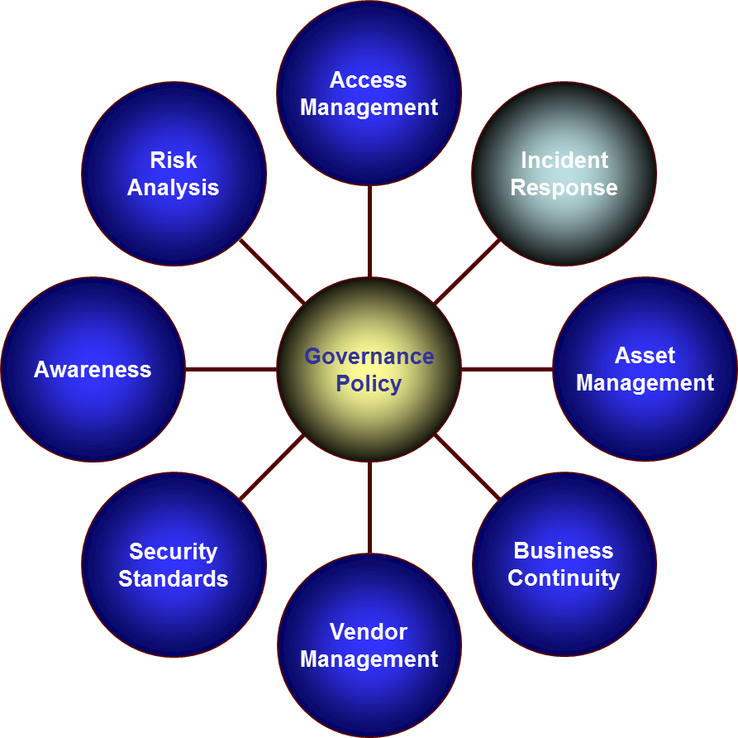

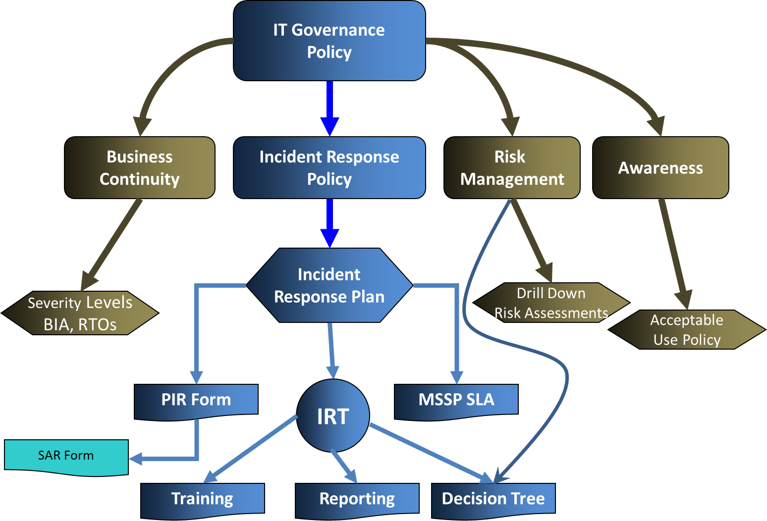

Insert Financial Institution Name / Logo

Incident Response Plan
(Approved During DD/MM/YY Incident Response Team Meeting)

Classified: Confidential Information
Contact if found: Name, Title
Name of Financial Institution
City, State

Plan Scope

This plan applies to all Name of Financial Institution’s [Computer Incident Response Team (Computer Incident Response Team) / Incident Response Team (IRT) / Technology Steering Committee] as well as all members of the Information Technology Team. A portion of this plan, related to Suspicious Activity Reporting, pertains to each and every member of the Information Technology Team.

The [Incident Response Team (IRT) / IRT / Technology Steering Committee / Disaster Recovery Team], through the leadership of the Information Security Officer, is responsible for overseeing the development, implementation, and maintenance of this plan. It should be reviewed at least annually to ensure relevant information is appropriately considered.

The Information Security Officer is responsible for enforcing this plan.

For questions concerning this plan, see [the Information Security Officer / Senior Management].

Introduction

The Board of Directors has approved an Incident Response Policy which provides for the creation of a [Incident Response Team (IRT) / IRT / Technology Steering Committee / Disaster Recovery Team] and directing that team to be led by the Information Security Officer. The policy also requires the creation of this Incident Response Plan, including:

- An Intrusion Detection Procedure that establishes an Intrusion Detection System and parameters related to maintaining this system;
- An Incident Response Plan that serves as a guideline for an overall approach to incidents;
- Processes for containment, eradication, recovery, and follow-up;
- A procedure that includes a severity rating assignment process for incident types;
- Notification requirements establishing guidelines for reporting incidents;
- Regular reporting requirements for summary reports to Management and the Board of Directors;
- Provisions for documentation of critical information necessary in the event of an incident; and,
- Guidelines for IT personnel to report observed suspicious activity (with suspicious activity triggers).
- Priorities to serve as a starting point for defining responses to incidents;
- An Incident Management Procedure that includes a Severity Rating Assignment Process that breaks all incident types into five levels which will be used to dictate reporting requirements as well as require an emergency [Incident Response Team (IRT) / IRT / Technology Steering Committee / Disaster Recovery Team] meeting.

Objective

Given the risk-based approach to Information Security and that there is no such thing as 100% security, management must create a proactive plan for addressing incidents where availability of information, integrity of information, or confidentiality of information is breached. Likewise, the plan should ensure that the financial institution properly addresses violations of the Acceptable Use Policy. The plan should establish the goals of good incident response, as well as priorities to enforce while in an incident.

Accordingly, the Federal Financial Institutions Examination Council (FFIEC) indicates that the IT operations management should implement corrective (incident response) security controls.

The Incident Response Policy also creates the [Computer Incident Response Team / IRT / Steering Committee] , establishing the membership, roles, responsibilities, and authority of the [Incident Response Team (IRT) / IRT / Technology Steering Committee / Disaster Recovery Team] . Note: Most banks are now calling this team the “Incident Response Team” because this policy governs more than just computer incidents.

Though for the purposes of creating an incident response process we will not include these types in our classification structures, it is helpful to know that the following types of negative actions can be considered to be a “technology incident.”

- Increased Access
- Disclosure of Information
- Corruption of Information
- Denial of Service
- Theft of resources
- Negative Reputation
- Negative Legal Implications

For the sake of this plan, an “incident” is anything that occurs that negatively impacts upon the institution, its employees, or its customers. This includes incidents related to [availability,] integrity, confidentiality, legal risk, and/or reputational risk. Incidents related to availability will be addressed by the Business Continuity Plan as per the Business Continuity Policy.

High Likelihood Response Scenarios

A secondary objective of this Incident Response Plan is to, with the assistance of the Incident Response Team, proactively develop incident response scenarios with plans surrounding those scenarios for the high-likelihood incidents as determined by our risk assessment process. Scenarios will be tested as per FFIEC Guidelines related to Disaster Recovery Testing. See Appendix B for these test scenarios.

Goals of an Incident Response

The main goals of a response to an incident are as follows:

- Proactive Goals
  - Assure integrity of critical information assets.
  - Detect intrusion, misuse, and other negative events.
  - Recover systems, data, and services.
  - Contain intrusions and negative incidents.

- Reactive Goals
  - Investigate the source or cause of an incident.
  - Facilitate and control communication with internal and external agencies.
  - Investigate in a manner that will allow prosecution where appropriate.
  - Feed the Suspicious Activity Reporting procedure.

- Reactive Proactive Goals
  - Allow for trend analysis, on-going risk assessment, and mitigation.
  - Educate the [Incident Response Team (IRT) / IRT / Technology Steering Committee / Disaster Recovery Team].
  - Heighten awareness of appropriate team members.
  - Consider the type of incidents that could occur

Priorities

The following priorities serve as a starting point for defining our organization's response:
- Protect human life and safety.
- Protect customer information and assure organizational data integrity.
- Maintain the financial institution’s reputation and control external communication.
- Prevent damage to systems.
- Minimize disruption of computing resources.

Types of Incidents

The [Incident Response Team (IRT) / IRT / Technology Steering Committee / Disaster Recovery Team] will classify all incidents into one of three types:
- Disclosure Incidents: These are incidents which, because of some statute or regulation, require [name of financial institution] to notify customers, law enforcement, examiners, or the board of directors. The [Incident Response Team (IRT) / IRT / Technology Steering Committee / Disaster Recovery Team] must comply with all applicable laws and regulations, including state laws such as [Indiana Code 24-9.4 / applicable law in your state] and the [FDIC’s Financial Institution Letter 27-2005, the OCC Supervisor Letter 2005-13, for Fed and NCUA institutions ---> the FFIEC’s Interagency Guidance on Response Programs for Unauthorized Access to Customer Information and Customer Notice] and/or any other applicable guidance or regulations as they are developed.
- Security Incidents: These are incidents related to the confidentiality and integrity of information. They can include technical incidents such as malware (virus, worm, and trojan horse) detection, unauthorized use of computer accounts and computer systems, but can also include non-technical incidents such as improper use of information assets as outlined in the Acceptable Use Policy.
- Negative Incidents: These are incidents related to the availability of information assets or other risks such as legal risks, strategic risks, or reputational risks that do not directly impact the confidentiality or integrity of information. For example, installing an unlicensed application on a bank-owned application does not impact confidentiality, integrity, or availability, but this policy still requires the [Incident Response Team (IRT) / IRT / Technology Steering Committee / Disaster Recovery Team] to track it.

The [Incident Response Team (IRT) / IRT / Technology Steering Committee / Disaster Recovery Team] may develop a severity classification system within each incident type. The Information Security Officer to report all Notification Incidents to the Board of Directors as they occur, and report [severe / critical] Security Incidents and [critical / severe] Negative Incidents as deemed necessary by the [Incident Response Team (IRT) / IRT / Technology Steering Committee / Disaster Recovery Team] in real time.

The Information Security Officer is authorized by the Incident Response Policy to classify incident types, as defined above, as well as incident severities. All incidents should be summarized by type and [criticality / severity] (as described below) in the Annual Report to the Board. This report should include status information for all “disclosure incidents.”

Authority

The Information Security Officer is authorized by the Incident Response Policy to declare incident categories as described above, as well as incident severities as described below, even if the [Incident Response Team (IRT) / IRT / Technology Steering Committee / Disaster Recovery Team] does not agree with such classification. The Information Security Officer is responsible for coordinating and training the [Incident Response Team (IRT) / IRT / Technology Steering Committee / Disaster Recovery Team] related to Incident Response duties. The Information Security Officer is responsible for documenting and reporting incidents as well as overseeing the proper execution of the incident response procedures. This includes reporting incidents to the Board of Directors, Management, the [Incident Response Team (IRT) / IRT / Technology Steering Committee / Disaster Recovery Team], regulatory agencies, and law enforcement personnel, as appropriate.

It is the responsibility of all staff to adhere to all Name of Financial Institution security policies and procedures, and promptly report information security incidents as defined in this policy. All Managers of the Information Technology staff are responsible for ensuring that incident reporting policy and procedures are communicated to and understood by all staff under their authority. The [Network Manager / Network Administrator] is responsible for immediately reporting all incidents, including unexplained system downtime, drastic changes in system performance, suspicious probes and browsing, and/or denials of service to the Information Security Officer. Detailed documentation describing the incident must also be submitted.

Only the following people have the responsibility and authority to define, set, and change firewall rulesets and routing controls; change or authorize change of IDS signatures; as well as affect any other device or software that has or may have an impact on the security of the network:

- IT Manager / Network Administrator
- Chief Information Officer
- Network Provider
- Managed Security Services Provider

Responsibilities
- The Information Security Officer is responsible for classifying the incident as [a critical incident / one potentially requiring immediate action] (and thus an emergency meeting of the [Incident Response Team (IRT) / IRT / Technology Steering Committee / Disaster Recovery Team] or a [minor / trend] incident requiring review in a [monthly / quarterly / periodic] [Incident Response Team (IRT) / IRT / Technology Steering Committee / Disaster Recovery Team] meeting.
- The Information Security Officer, working with the [Incident Response Team (IRT) / IRT / Technology Steering Committee / Disaster Recovery Team], will what type of communication is required, the content of the communication, who should receive the communication, and how best to distribute the communication.
- The Information Security Officer is responsible for initiating, completing, and documenting the incident investigation with assistance from the [Incident Response Team (IRT) / IRT / Technology Steering Committee / Disaster Recovery Team].
- The Information Security Officer is responsible for managing and collecting forensic evidence, and will act as the contact person between the financial institution and law enforcement.
- The [Public Relations Officer / President / Marketing Director] is responsible for coordinating communications with outside organizations.
- In the event of internal policy violations, the Human Resources Department will recommend disciplinary actions, if appropriate, to the [Incident Response Team (IRT) / IRT / Technology Steering Committee / Disaster Recovery Team].

Incident Response Tests

The Information Security Officer will plan for and coordinate testing of the Incident Response Program.
These tests should be conducted on an annual basis at least twice, and one of the tests should be of a scenario which would be classified as a “Disclosure Incident.” All Incident Response Team members should attend the tests. Tests should include a test plan, minutes of the actual test, and documentation of a “post-mortem review.” Test results should be presented to the board. A walk-through test should be conducted when the plan is updated. A tabletop test should be conducted against a high likelihood “incident scenario.” Functional tests, conducted during social engineering portions of audits or internally, should also be conducted.

Broadcast Awareness

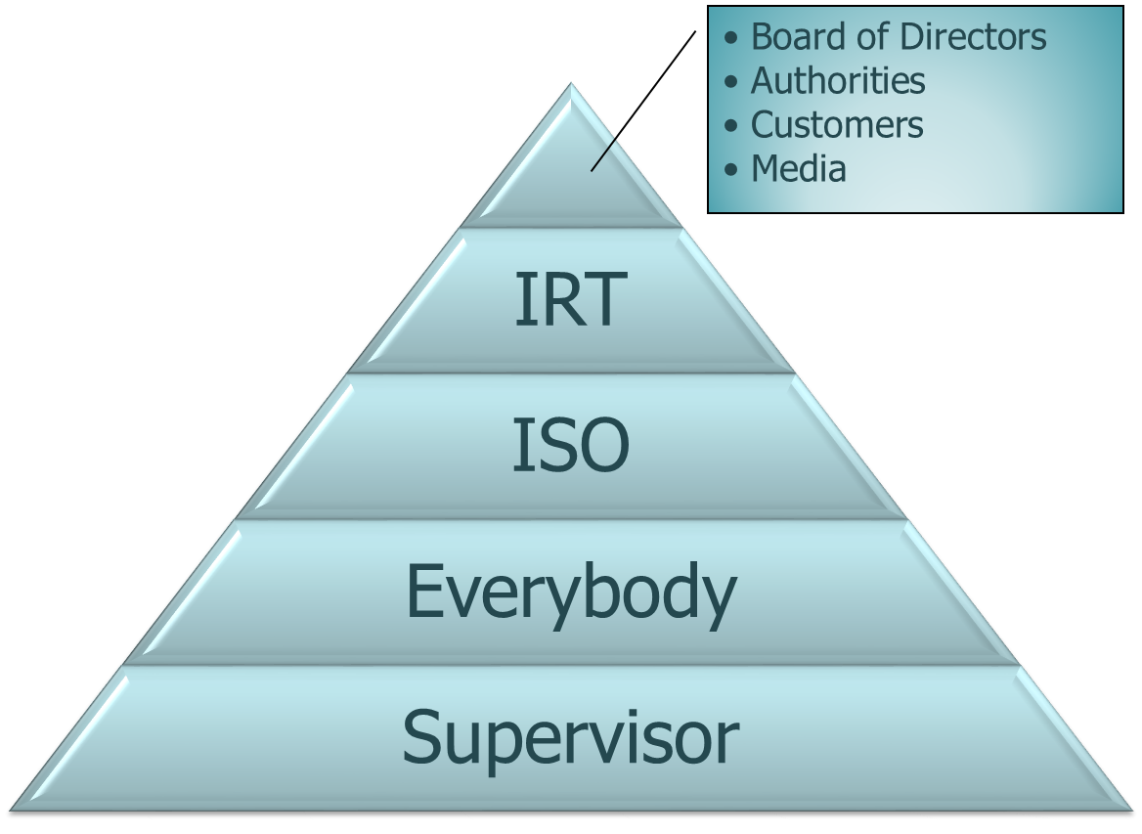
The Information Security Officer will create, publish, and maintain a process for quickly moving through “triage” on new incidents. This process will be named “Broadcast Awareness,” and should be addressed in the Acceptable Use Policy as well as in annual awareness training. Whenever possible, the time to broadcast awareness should be measured in tests and incidents. The Information Security Officer should work with auditors to determine broadcast awareness time during social engineering steps as well as block time on IPS systems. Broadcast Awareness should be determined, when possible, as a metric during a live incident. The process should articulate what happens from the time an employee becomes suspicious until when we notify the media (see diagram to left.)

First Priority in an Incident

The incident response team will be trained that the first priority in an incident is to contain the incident . . . stop any further damage from being incurred. All users will be taught a “last resort response . . . . go into ‘airplane mode’” during suspected incidents.

Incident Response Team Steps

For those not involved in “containing” an incident, the first three steps in an incident should be to 1) Broadcast Awareness, 2) Inform the Information Security Officer, and 3) assist in the Triage process.

Triage

Triage is the name of our process for determining the scope and nature of an incident, resulting in the classification, documentation, and escalation (if necessary) of the incident in a timely manner. The three-step process is as follows:

  - Detect: Broadcast Awareness
  - Assess: Real or potential unauthorized access to customer data? Who, what, when, how, where?
      - Has misuse occurred?
      - Or is there a potential that misuse could occur?
  - Respond: Classify, Document, Escalate!

Response Cycle

The Incident Response Team will be trained on the NIST Response Cycle as indicated in the following drawing:

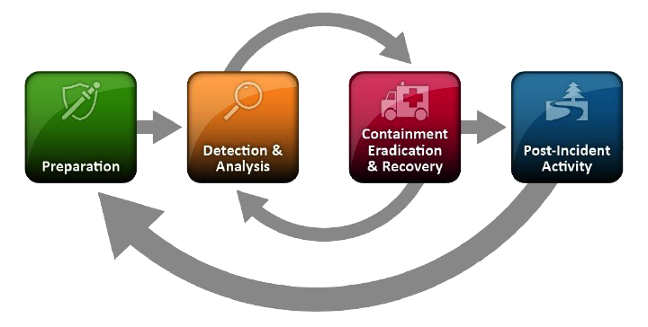

When Customer Notice is required

Guidance maintains that <Name of Financial Institution> must notify customers whenever it becomes aware of an incident of unauthorized access to customer information and, at the conclusion of a reasonable investigation, determines that misuse of the information has occurred or it is reasonably possible that misuse will occur.

Notification Tactics

Customer notice should be given in a clear and conspicuous manner. The notice should

include the following items:

Description of the incident;

Type of information subject to unauthorized access;

Measures taken by the institution to protect customers from further unauthorized

access;

Telephone number customers can call for information and assistance; and

Remind customers to remain vigilant over next twelve to twenty four months, and report suspected identity theft incidents to the institution.

The guidance encourages financial institutions to notify the nationwide consumer reporting agencies prior to sending notices to a large number of customers that include contact information for the reporting agencies.

Delivery of Customer Notice

Customer notice should be delivered in a manner designed to ensure that a customer can reasonably be expected to receive it. For example, the institution may choose to contact all customers affected by telephone or by mail, or by electronic mail for those customers for whom it has a valid e-mail address and who have agreed to receive communications electronically.

Compliance steps to Following during a Disclosure Incident

Guidance maintains that the following steps be followed in an Incident Response:

  - Triage: Assess nature and scope of incident and determine if customer notification is required. (Determine Disclosure Requirements)
  - Notify your federal regulator.
  - File a timely SAR.
  - Contain and Control
  - Notify Customer

We will of course contain an incident as a first priority. The above identifies the compliance steps that must be followed in an incident.

Risk Monitoring

The Information Security Officer will ensure that the Incident Response Team is monitoring accepted risk. When the Board of Directors accepts the risk on various information assets, this acceptance is based upon the understanding that the Incident Response Team is monitoring for a threat exploiting a vulnerability for known accepted risks. The Incident Response Team will be responsible for monitoring non-technical risk. The Information Security Officer may outsource, with Board approval, the monitoring of some technical risk. The Board of Directors requires that the Incident Response Team adopt [the NIST CyberSecurity Framework | NIST SP 800-61 | the FFIEC Guidelines] as the framework for which Risk Monitoring will be audited against. The Information Security Officer will inventory and/or diagram layers of risk monitoring controls.

Intrusion Detection Procedure

- Our intrusion detection is outsourced to a Managed Security Service Provider (MSSP). We have on file an agreement that the Intrusion Detection System (IDS) will be monitored 24x7x365. This agreement also provides for an 8 hour guaranteed response to any and all detectable intrusions.
- All financial institution employees will be trained to “broadcast awareness,” meaning inform all appropriate persons in real time of suspicious activities. Then, all suspected and/or confirmed instances of attempted and/or successful intrusions must be immediately reported to the Information Security Officer.
- Information Technology Team Members will be trained by the Information Security Officer how to report potential issues they may discover as they troubleshoot and maintain the system, to the [Incident Response Team (IRT) / IRT / Technology Steering Committee / Disaster Recovery Team] for investigation.
- All incidents will be carefully assessed by the Information Security Officer to determine appropriate action and ensure necessary reporting requirements are met. Reporting based on system availability and customer information breach is described below. Still, not all incidents are easily predicted in terms of reporting requirements, and the Information Security Officer will need to make judgment calls based on the situation. As a general rule, reporting to the [Incident Response Team (IRT) / IRT / Technology Steering Committee / Disaster Recovery Team] will be required if the incident expands into an official investigation or there is a need to counsel an individual through Human Resources.
- Based on the nature and scope of the incident, technical staff and the Information Security Officer shall decide whether the incident can be resolved locally or whether additional assistance is required from the [Incident Response Team (IRT) / IRT / Technology Steering Committee / Disaster Recovery Team] or other outside sources.
- Operating system, user accounting, and application software audit logging processes must be enabled on all host and server systems.
- Alarm and alert functions of any firewalls and other network perimeter access control systems must be enabled.

Incident Response Questions

At the Information Security Officer’s discretion, based on the type of incident, the overall approach to an incident may be determined after answering questions as follows:

- Overview - What are the goals and objectives in handling the incident?
- Evaluation and Classification - How serious is the incident? Assign a Severity Rating.
- Notification - Who should be notified about the incident?
- Response - What should the response to the incident be?
- Legal/Investigation - What are the legal and prosecutorial implications of the incident?
- Documentation Logs - What records should be kept from before, during, and after the
incident?

Response Guidelines

At the Information Security Officer’s discretion, based on the type of incident, the actual response to an event may fall into the general categories of containment, eradication, recovery, and follow-up. Response usually occurs concurrently with overview, evaluation, and notification. Timely response is, of course, one of the keys to mitigating damage.
- Containment: The purpose of containment is to limit the extent of an attack. For example, it is important to limit the spread of a worm attack on a network as quickly as possible. An Incident Response Decision Tree is on file at our managed security service provider’s NOC, where predetermined containment procedures have already been addressed. An essential part of containment is assigning a severity rating to the incident as well as decision making (i.e., determining whether to shut a system down, to disconnect from a network, to monitor a system or network activity, to set traps, to disable functions such as remote file transfer on a UNIX system). Notification occurs during this stage.
- Eradication: Once the incident has been contained, it is now time to eradicate the cause. Eradication software is available to eliminate most viruses that infect small systems. Ensure all backups are clean. Many systems infected with viruses become re-infected periodically because people do not systematically eradicate the virus from backups.
- Recovery: The goal of recovery is to return the system to normal. In the case of a network-based attack, it is important to install patches for any operating system vulnerability which was exploited. All compromised systems are to be restored before reactivation.
- Follow-up: Follow-up should include regular status reporting, describing new controls and “lessons learned” to improve future performance.
The most important element of the follow-up stage is performing a postmortem analysis of the response procedure itself. Exactly what happened and at what times? How well did the staff involved with the incident perform? What kind of information did the staff need quickly, and how could they have received that information as soon as possible? What would the staff do differently next time? Creating a formal chronology of events (including time stamps) is also important for legal reasons. Similarly, it is important to quickly obtain a monetary estimate of the amount of damage the incident caused in terms of any loss of software and files, hardware damage, and manpower costs to restore altered files, reconfigure affected systems, and so forth. This estimate may become the basis for subsequent prosecution activity.

Forensic Investigation

When an incident is a result of a computer crime or has the potential of being part of a legal proceeding, evidence can be derived from computers and then used in court against suspected individuals. Computer evidence is like any other evidence; it must be authentic, accurate, complete, convincing to juries, and in conformity with common law and legislative rules. Thus, the evidence gathered from suspected computer-related crimes must conform to the same standards as other evidence to be credible.

The Information Security Officer is responsible for managing the collection of forensic evidence. The IT Manager and Information Security Officer will proactively establish standards and rules related to forensics evidence collection. (Note: use last sentence if the following is not used.) The following rules will be followed:
- Ensure that no forensics evidence is damaged, destroyed or otherwise compromised by the procedures used during the investigation.
- Never work on the original evidence.
- Establish and maintain a continuing chain of custody.
- Document everything.
- Consider hiring a third party to collect evidence in a forensics-proof manner. The independence of a third party will increase credibility of evidence, and the appropriate vendor will be trained to identify, acquire, and preserve evidence in the proper manner, as well as keep a proper chain of custody.
- The Information Security Officer has the authority to hire and/or retain a third party to collect Forensics data so that independence is established and there is no appearance of a conflict of interest.

Definition of “Real Time”

The Incident Response Policy requires the Information Security Officer to keep the Board of Directors informed, in “real time,” during Disclosure Incidents. For the purposes of policy compliance, we define “real time” as a steady stream of information provided as needed and reasonable, at the Information Technology Committee’s discretion, as it determined to be appropriate. To clarify, while the Board may be updated “in real time,” customers are rarely notified in real time, because we do not know if the information is complete and accurate.

Severity Rating Assignment

Some organizations will assign a “disaster/availability” criticality to appropriate incidents and continue to track, monitor, and report on it in the Incident Response Program. However, other banks will only use two severity ratings (Minor and Critical, for example) and refer all availability related incidents, even if created by viruses or other denial-of-service attack vectors, to the disaster recovery component of the business continuity plan, and track, monitor, and report on it from there.

To simplify the response process, the Information Security Officer will assign one of [three / two] severity ratings to incidents as they are reported.

- [Minor / Trend] Incident: This incident is low risk and, though [may/should] be monitored and reported in an upcoming [Incident Response Team (IRT) / IRT / Technology Steering Committee / Disaster Recovery Team] meeting, does not warrant immediate action or reporting.
- [Critical / Severe / Emergency] Incident: This incident requires an emergency [Computer Incident Response Team / Incident Response Team / Steering Committee] Meeting to determine response actions, notification requirements, etc.

Note: Some banks do not specify disaster incidents as a third incident, and just have the second paragraph below.

- Disaster (Availability) Incidents: This incident requires execution of the Disaster Recovery Plan, and will defer to response processes and severity ratings in that plan. . . . or . . .

Disaster Incidents: Some incidents require execution of the Business Continuity Plan, and will defer to response processes and severity ratings in that plan, as decided by the Information Security Officer.

Or, for larger organizations, the following may be used in place of the above simplified severity classification scheme:

In order to identify the scope and impact, a set of criteria should be defined which is appropriate to the site and to the type of connections available. Critical questions must be asked to help determine the severity of the incident.

- Is there a possibility the a possibility that we will need to notify our customers?
- Is this a multi-site incident?
- Are many computers at your site affected by this incident?
- Is sensitive information involved?
- What is the entry point of the incident (network, phone line, local terminal, etc.)?
- Is the media involved?
- What is the potential damage of the incident?
- What is the estimated time to close out the incident?
- What resources could be required to handle the incident?

Note: Even smaller institutions, if not including the above in their actual plan, may want to have a separate “tool or standards” document with the above questions to assist in an incident.

In order to ensure a response process that assures prompt notification of senior management and the board as dictated by the probable severity of damage and potential monetary loss related to adverse events, the Information Security Officer must review all incident reports to sort between the following levels of severity:

Level 1) Minor Incident
No interruption in data processing operations.

All incidents that will not affect operation of business but need to reported to Management/[Incident Response Team (IRT) / IRT / Technology Steering Committee / Disaster Recovery Team] in monthly written reports.

Level 2) Reportable Incident
Some computer facility and/or computer equipment damage or an interruption in critical services is observed, but operations can be resumed within 12 hours. Note: equalize this time-frame to the financial institution’s Disaster Recovery Plan. Any incident which has disabled or will disable, partially or completely the central computing facilities, and/or the communications network for a period of 12 hours or less.

OR Any security incident which has been successfully responded to and which does not have the potential, over time, to affect inherent operational or reputational risk.

Level 3) Major Incident:
Moderate damage to the computer facility and/or the computer equipment or an interruption in critical services is observed, but operations can be resumed within 12 to 40 hours. Note: equalize this to the financial institution’s Disaster Recovery Plan. User departments would experience two or less working days delay of updated information. Any incident which has disabled or will disable, partially or completely the central computing facilities, and/or the communications network for a period of more than 12 to 40 hours.

OR Any security incident which it is clear that a person has been specifically targeting the financial institution for the purpose of breaching security.

Level 4) Critical Incident:
Any incident which has disabled or will disable, partially or completely the central computing facilities, and/or the communications network for a period of more than 12 to 48 hours. Note: equalize this to the financial institution’s Disaster Recovery Plan.

AND/OR Any security incident which it is clear that a person has breached security of the financial institution or for some other reason the Information Security Officer determines that the [Incident Response Team (IRT) / IRT / Technology Steering Committee / Disaster Recovery Team] may want to consider involving law enforcement.

AND/OR Any event that may increase reputational or legal risk if not addressed immediately.

AND/OR Any security incident in which protected customer information has been breached.

Level 5) Disaster:
Any Level 3 incident which has disabled or will disable, partially or completely the central computing facilities, and/or the communications network for a period of more than 48 hours. Note: equalize this to the financial institution’s Disaster Recovery Plan.

Critical Information Storage

A Managed Security Service Provider will be required to host an offsite, secure “information safe” in which the following will be stored and kept current:
- Corporate Disaster Recovery Plan
- Shared Passwords
- Network Diagram
- Organizational Calling Tree and Distribution List

Risk Monitoring and Preventive Controls

Note: List the types of detective, preventive, and monitoring controls the Organization uses for cybersecurity incidents.

The Network Administrator is responsible for maintaining the following automated systems, which are in place to prevent an incident:

- Virus Prevention: Name of Financial Institution uses [name of virus protection package] to detect, quarantine, and remove viruses. The package is installed on the [name of server] and feeds DATS to all workstations [hourly / daily / weekly / as-needed]. Workstations are audited [quarterly / semi-annually] as well as randomly to establish that DATs are current. See the Virus Incident Response Procedure for more details.

- Spam Filtering: Name of Financial Institution uses a multi-layered spam defense approach, starting with [name of spam filter] which is a[n] [server-based / network device / off-site] spam filter. False positives go to [individual user / supervisor / departmental / central] quarantines and users [log in to / request reviews of / can directly review] the quarantine to review the quarantine to release legitimate messages. Users can also identify spam (delivered messages that should have been filtered). The system learns from such activity. The [Offsite Filtering / Spam Filtering] system also filters viruses, adding an additional layer of protection to our existing virus protection strategy.

- Content Filtering: Name of Financial Institution uses [name of content filter] which blocks requests for certain URL’s that are considered inappropriate. Users that need temporary access to certain web pages that may request an exception to the content filtering policy. The [Network Administrator] approves such exceptions. Policies are established based on the [Network Administrator]’s interpretation of the Acceptable Use Policy. Lexicons related to sites that expose Name of Financial Institution to legal risk, such as pornographic, illegal, hate-based, and other offensive websites are turned on. Other lexicons which are turned on include [e-commerce sites such as e-bay, chat room sites, list sites here].

- Spyware Screening: Name of Financial Institution uses [name of spyware screening software] to block spyware at the perimeter of the network. The Intrusion Detection System [also] functions in this capacity.

- Intrusion Prevention System: Name of Financial Institution uses [name of IPS/IDS system] to monitor all network traffic. The preventive functionality of this system works in a “blocking mode,” meaning that it provides a preventative control by automatically blocking certain incident types, such as spyware, vulnerability scans, etc.

- Intrusion Detection System: Name of Financial Institution uses [name of IPS/IDS system] to monitor all perimeter and internal network traffic that cannot be blocked with an Intrusion Prevention System. This system creates a detective control,, and Name of Financial Institution outsources the monitoring of this system so that incidents can be responded to in real time.

- Event Log Management System (SIEM): Name of Financial Institution uses [name of IPS/IDS system] to monitor all critical logs generated by critical information assets. Correlation of logs to network traffic is handled by [name of IPS/IDS provider.] Log analysis definitions are kept by the Information Security Officer. (Note, some MSSPs won’t share this information.)

- File Integrity Checking Processes: Name of Financial Institution has the following “change detection” processes in place: Web Defacement Monitoring provided by [name of company.] Change Detection (of port modifications) on the firewall using [name of system.] File integrity checks on the firewall rules file using [name of system.] Describe other file integrity checking processes in place.

- Social Media Monitoring: Name of Financial Institution uses processes defined below to monitor the internet for the bank’s name and derivatives of the bank’s name. In the event a negative comment is published about the bank, appropriate persons are notified according to the decision tree.

- Other Third Party Monitoring: Third parties offer a variety of subscription-based and free monitoring services. An example is fraud detection services that will notify an organization if its IP addresses, domain names, etc. are associated with current incident activity involving other organizations. There are also free real-time blacklists with similar information. Another example of a third-party monitoring service is a CSIRC notification list; these lists are often available only to other incident response teams. Document any arrangements you have made here.

- Incident Response Team: We use our Incident Response Team to monitor for threats exploiting vulnerabilities in a manner that cannot be detected by technical controls. For example, the world’s greatest is not going to detect a pretext call. Thus, the following roles have been assigned:
  - Human Resources: Monitors for policy violations, internal threats, employees in financial trouble, and security awareness issues.
  - Marketing: Monitors for media threats, inappropriate social media posts, customer awareness issues. Also prepares for customer notification and media engagement.
  - Identify a Person: Monitors FS-ISAC.
  - Identify a Person: Engages with law enforcement and brings any news to the Incident Response Team meetings.
  - Identify a Person: Engages with the [State Banking Association]
  - Identify a Person: Engages with [Infragard, Cert, Local Organizations, etc.]

Managed Security Provider Response Procedures

Note: The following procedure is based on the infotex Controlled Response IPS system . . . you will need to tailor this to your own MSSP.

- The procedures for initial response and containment for all incidents by type are documented in the Incident Response Decision Tree.
- The procedures for notification of incidents as they occur are documented in the Communication Methodology of the Managed Security Service Provider’s portal.
- Necessary passwords for response to incidents in real time are secured offsite in the Information Safe.
- Some Incident Response Procedures place the containment and eradication back in the hands of our IT staff. In general, these are usually virus incidents, compromised website incidents, and some network incidents.
- Specific Procedures for response to Virus Incidents, Compromised Website Incident, and Network Incidents are addressed in separate documents (see supporting information below).
- Almost always the follow-up phase of intrusion response is handled by the [Incident Response Team (IRT) / IRT / Technology Steering Committee / Disaster Recovery Team] as per the Policy Rules in the Incident Response Policy.

Managed Security Service Provider Requirements

The MSSP is required to:
- Utilize CISSP personnel to design, manage, and oversee the [SOC / NOC];
- Conduct background checks on all NOC personnel;
- Submit financial statements for review annually;
- Maintain a nondisclosure agreement;
- Maintain a provable chain of custody for the preservation of potential evidence through such mechanisms as a detailed action and decision log indicating who made each entry.

In addition to the normal vendor management responsibilities, a successful engagement with an MSSP should include:

- A contract with mutually agreed upon Service Level Agreements (SLAs);
- Strategies for ensuring transparency and accountability that include:
- Regular communication between the FI and the MSSP on
- matters including change control, problem resolution,
- threat assessments, and MIS reporting,
- Descriptions of processes for physical and logical controls over bank data; and,
- Periodic review of the MSSP's processes, infrastructure, and control environment through offsite reviews of documentation and onsite visitations.

See FFIEC Guidelines for managing an MSSP (Appendix D of the IT Examination Handbook).
Furthermore, the MSSP must provide third-party assurance that the following is in place:
- Adequate controls used to detect and respond to unauthorized activities;
- Schematics of the information technology systems for common intrusion detection systems;
- Assurance that an appropriate firewall ruleset and routing controls are in place and updated as needs warrant;
- Assurance that appropriate filtering occurs for spoofed addresses, both within the network and at external connections, covering network entry and exit;
- Assures that logs of security related events are sufficient to assign accountability for intrusion detection system activities, as well as support intrusion forensics and IDS;
- Appropriately secures logs of security related events against unauthorized access, change, and deletion for an adequate time period, and that reporting to those logs is adequately protected;
- Has in place an appropriate process exists to authorize employee access to intrusion detection systems and that authentication and authorization controls limit access to and control the access of authorized individuals.

Managed Security Service Provider (MSSP) Service Level Agreement (SLA):

The following is a summary of the Service Level Agreement with the MSSP:

  - Start Date: xx/xx/xx
  - Expiration Date: xx/xx/xx
  - Renewal Terms: Month to Month
  - Guaranteed Response Time: x Hours
  - Intrusion Prevention on the Network Perimeter: Yes
  - Intrusion Detection on the Network Perimeter: Yes
  - Intrusion Prevention on the Internal Network: Yes
  - Intrusion Detection on the Internal Network: Yes
  - Real-time monitoring of critical event logs: Yes
    - Definition of Critical Logs: As per below
  - Collection and Forensics Archival of Logs: As per below
  - Ability to provide trend reports to IRT Meetings: IPS/IDS only
  - Change control on the firewall.
  - Web Defacement Monitoring
  - List other services here . . .

Definition of Critical Logs

By default: the following log events are monitored as the system is polled (every 15 minutes) and, when occurring, triggers an immediate reaction via the Infotex 24x7x365 Network Operations Center team:

  - Disk Capacity Failures
  - Unexpected Server reboots
  - Windows Update Failures
  - Licensing Errors
  - Hardware Errors (as requested by Client during tuning)
  - Backup Errors (as customized to Client during tuning)
  - DNS Errors (as requested by Client during tuning)

Collection, Consolidation, and Forensics Archival of Logs:

  - Account Management – Success / Failure
  - System Events – Success / Failure
  - Directory Service Access – Success / Failure
    - Active Directory Object Access Attempts – Success / Failure
    - Active Directory Object Deletions
    - Group Policy Management
    - User account changes that provide administrator equivalent permissions.
    - Changes to Groups --- adds, changes, or deletions. .
  - Password Reset Attempts by Users
  - Password Reset Attempts by Administrators or Account Operations
  - Login Events – Success / Failure
  - Disk Capacity Failures
  - Manual changes to the registry – adds, changes, and deletions.
  - AVS Application Update errors (as customized by Client during tuning)
  - AVS DAT Update Errors (as customized by Client during tuning)
  - Unexpected Server reboots
  - Access to Network Infrastructure
  - Changes to ACL’s on switches, routers, or firewalls (assuming client includes these
  - assets)
  - Windows Update Failures
  - Licensing Errors
  - Hardware Errors (as requested by Client during tuning)
  - Backup Errors (as customized to Client during tuning)
  - DNS Errors (as requested by Client during tuning)

Notification Requirements

External communications to customers, law enforcement and/or the media must be reviewed by the [Incident Response Team (IRT) / IRT / Technology Steering Committee / Disaster Recovery Team], and presented to Management for approval prior to releasing it to the public. Specifically:

Customer Notification (Disclosure Incidents): [Indiana Law (Indiana Code section 24-4.9) / Applicable Local Laws] and FIL-27-2005 requires notification of customers in the event a breach of security jeopardizes non-public customer financial information. Specifically, FIL-27-2005 requires a five step process to be completed in order to respond to Disclosure Incidents:

- Assess the nature and scope of the incident and identify what customer information systems and types of customer information have been accessed or misused;
- Notify your primary federal regulator as soon as possible when the institution becomes aware of an incident involving unauthorized access to or use of sensitive customer information;
- File a timely SAR, and in situations involving federal criminal violations requiring immediate attention, such as when a reportable violation is ongoing, promptly notify appropriate law enforcement authorities;
- Take appropriate steps to contain and control the incident to prevent further unauthorized access to or use of customer information; and
- Notify customers when warranted in a manner designed to ensure that a customer can reasonably be expected to receive it.

Furthermore, FIL-27-2005 defines customer information as:
- A customer’s name, address or telephone number in conjunction with the customer’s Social Security number, driver’s license number, account number, credit or debit card number, or a personal identification number or password that would permit access to the customer’s account.
- The FFIEC’s definition also includes any combination of components of customer information that would allow someone to log on to or access the customer’s account, such as user name and password or password and account number.

Finally, FIL-27-2005 clarifies the timeframe we must follow for determining WHEN a customer is notified as follows:
- A financial institution should provide a notice to its customers whenever it becomes aware of an incident of unauthorized access to customer information and, at the conclusion of a reasonable investigation, determines that misuse of the information has occurred or it is reasonably possible that misuse will occur.

In this type of incident, the [Incident Response Team (IRT) / IRT / Technology Steering Committee / Disaster Recovery Team] will determine if legal counsel must be involved. Notification should include the date of the breach and the types of information that was breached. Notification should be reviewed by the PR / Marketing member of the [Incident Response Team (IRT) / IRT / Technology Steering Committee / Disaster Recovery Team] prior to delivery. The Board of Directors must be notified in the event of a Disclosure Incident.

Law Enforcement Notification: Law Enforcement will be notified if the incident warrants a criminal investigation. This includes, but is not limited to, theft of computer equipment or software, destruction of or tampering with government equipment, illegal Internet activity, electronic mail that poses a threat to customers or staff and falsifying or stealing information contained in company systems. Investigative procedures will be followed to determine if criminal activity occurred. Pending preliminary investigation results, the Director of Security will work with law enforcement to meet further reporting requirements. The [Incident Response Team (IRT) / IRT / Technology Steering Committee / Disaster Recovery Team] and Management will be kept informed of the progress of the investigation as changes in the status of the investigation occur.
If law enforcement must be notified and an investigation initiated, a Suspicious Activity Report (SAR) must be filed with the Financial Crimes Enforcement Network (FinCEN). It is up to the [Incident Response Team (IRT) / IRT / Technology Steering Committee / Disaster Recovery Team] ’s discretion as to whether incidents warrant the involvement of Law Enforcement and/or submission of a SAR to FinCEN. Note however, that Bank Secrecy Act regulations require every financial institution to file a report of any suspicious transaction relevant to a possible violation of law or regulation.

Board of Directors: The Board of Directors will be informed, in real time, of any incidents which require notification of customers, law enforcement, or other government agencies. Non-critical disclosure incidents still require board notification, but it can be part of a monthly report to the board. The Board of Directors will also receive a summary of incidents annually in the Annual Information Security Report to the Board.

One of the most important issues to consider is when, who, and how much to release to the general public through the media. There are many issues to consider when deciding this issue. First and foremost, if a public relations office exists for the financial institution, it is important to use this office as a liaison to the media. The public relations office is trained in the type and wording of information released and will help to assure that image is protected during and after the incident (if possible). Involving the public relations office in the [Incident Response Team (IRT) / IRT / Technology Steering Committee / Disaster Recovery Team] substantially reduces reputational risk. A public relations office has the advantage to communicate candidly with Point of Contact (POC) and then act as a buffer to the media so that control over the incident is maintained.

If a public relations officer is not available, the information released to the media must be carefully considered. If the information is sensitive, it may be advantageous to provide only minimal or overview information to the media. It is quite possible that the perpetrator of the incident will quickly review any information provided to the media.

While it is difficult to determine in advance what level of detail to provide to the media, some guidelines to keep in mind:
- Keep the technical level of detail low. Detailed information about the incident may provide enough information for copycat events or even damage the company's ability to prosecute once the event is over.
- Keep speculation out of media statements. Speculation of whom is causing the incident or the motives are very likely to be in error and may cause an inflamed view of the incident.
- When necessary, the Information Secuirty Officer will work with law enforcement professionals and/or third-party forensics experts to assure that evidence is protected. If prosecution is involved, assure that the evidence collected is not divulged to the media.
- Try not to be forced into a media interview before you are prepared. The popular media is famous for the “2 a.m.” interview, where the hope is to catch the interviewee off guard and obtain information otherwise not available.
- Do not allow the media attention to detract from the handling of the event. Always remember that the successful closure of an incident is of primary importance.

When the incident is closed, the [Incident Response Team (IRT) / IRT / Technology Steering Committee / Disaster Recovery Team] (or a designated party) will report the following:
- a description of the incident;
- the response process;
- the notification process;
- the actions taken to prevent further breaches of security.

Furthermore, a Suspicious Activity Report may be filed, at the BSA Officer’s discretion with the appropriate authorities.

Consider using this for larger organizations:
Upon assigning the Severity Level, the Information Security Officer in coordination with the [Incident Response Team (IRT) / IRT / Technology Steering Committee / Disaster Recovery Team] must then implement proper reporting as follows:

Reporting to Management: Any Severity Level 5 incident (disaster) will immediately trigger execution of the financial institution’s Disaster Recovery Plan. Levels 3 and 4 will require an immediate meeting of the [Incident Response Team (IRT) / IRT / Technology Steering Committee / Disaster Recovery Team] and Management will be informed immediately. Level 2 incidents will require a report to the [Incident Response Team (IRT) / IRT / Technology Steering Committee / Disaster Recovery Team] and further review in the next regularly scheduled [Incident Response Team (IRT) / IRT / Technology Steering Committee / Disaster Recovery Team] meeting. Level 1 incidents will be included in monthly reports to the [Incident Response Team (IRT) / IRT / Technology Steering Committee / Disaster Recovery Team] and Management.

Outreach Strategy: For Severity Levels 4 and 5 a press release must be drafted, reviewed by the [Incident Response Team (IRT) / IRT / Technology Steering Committee / Disaster Recovery Team] , and presented to Management for approval prior to releasing it to the press. The purpose of the press release is to mitigate damage to the financial institution’s reputation. Accomplish this by assuring that depositor’s money is safe and that security arrangements are being made. In the event of a breach of protected customer information assure the media that forensics are being arranged and the extent of the problem determined, and that all affected customers will be informed once the true nature of the damages are known. Refer to the financial institution’s Business Continuity Plan for more information related to dealing with the media.

Information Sharing Procedures: In the event of incidents at Levels 3 or 4, documentation of the breaches must be shared in compliance with the financial institution’s business continuity plan:

Either insert the Public Relations guideline from the Business Continuity Plan [which should list regulatory bodies, media contacts, etc.] into this point, or include the following reference: See Business Continuity Plan Section [identify section.]

Law Enforcement Notification: For Severity Level 3, 4 and 5 incidents, law enforcement must be notified and an investigation initiated. A Suspicious Activity Report (SAR) must be filed with the Financial Crimes Enforcement Network (FinCEN). IDS forensics must be initiated. Security Vendors must be contacted to assist with documentation and forensics efforts.

The SAR should be filed with FinCEN no later than 30 calendar days after the date of initial detection by the institution of facts that may form the basis for filing a SAR. If no suspect was identified on the date of the detection of the incident requiring the filing, an institution may delay their filing for an additional 30 calendar days to identify a suspect. In no case can an institution delay filing a SAR by more than 60 days after the date of initial detection of a reportable transaction. Finally, if the situation requires immediate attention, the institution is expected to notify appropriate law enforcement by telephone in addition to filing a SAR.

It is up to the [Incident Response Team (IRT) / IRT / Technology Steering Committee / Disaster Recovery Team] ’s discretion as to whether Level 2 incidents warrant the involvement of Law Enforcement and/or submission of a SAR to FinCEN. Note however, that Bank Secrecy Act regulations require every financial institution to file a report of any suspicious transaction relevant to a possible violation of law or regulation. Under the law, a SAR is triggered if the dollar amount involves at least $5,000 in funds or other assets and the institution knows, suspects or has reason to suspect that the transaction involves:

- Funds derived from illegal activity;
- Attempts to evade any requirements under the Bank Secrecy Act; or,
- No apparent business or lawful purpose or is not the sort of transaction in which the particular customer would normally be expected to be engaged in.

The Board of Directors must be notified when a SAR has been submitted.

Interface with Disaster Recovery/Business Continuity: In the event of a Severity Level 4 incident, the current IDS system vendor must be contacted as per Business Continuity Plan and arrangements for a replacement system made if determined necessary (alternative site in place more than X days or as determined by [Incident Response Team (IRT) / IRT / Technology Steering Committee / Disaster Recovery Team] ).

- Point of Contact (POC) people (Technical, Administrative, Response Teams, Investigative, Legal, Vendors, Service providers), and which POCs are visible to whom.
- Wider community (users).
- Other sites that might be affected.

Regular Reporting Requirements

Monthly summary reports will be submitted to the [Incident Response Team (IRT) / IRT / Technology Steering Committee / Disaster Recovery Team] and then to Management.

Service Availability Reports: These reports will include statistics regarding the frequency and duration of service disruptions, including the reasons for any service disruptions (maintenance, equipment/network problems, security incidents, etc.); “up time” and “down time” percentages for website and e-banking services; and volume and type of website access problems reported by e-banking customers.

Security Incident Reports: These reports will include volume of rejected log-on attempts, password resets, attempted and successful penetration attempts, number and type of trapped viruses or other malicious code, and any physical security breaches. Critical severity incidents will be detailed in this report.

All severity levels 1, 2, 3, and 4 incidents will be detailed in the report, accompanied by a current status of the incident.

Detailed Follow-up Reports: These reports are initiated by the severity rating assignments, and will be required by the [Incident Response Team (IRT) / IRT / Technology Steering Committee / Disaster Recovery Team] until any incident above Level 0 is closed as fully investigated. They must include all information described in the response process above.
Other reports to consider:

- Incidents Per Month
- Total Alerts
- Ticket Summary
- Pie Chart showing Severity Ratings

[Incident Response Team (IRT) / IRT / Technology Steering Committee / Disaster Recovery Team] Meeting Agenda and Minutes

The Information Security Officer will create a [Incident Response Team (IRT) / IRT / Technology Steering Committee / Disaster Recovery Team] Meeting Agenda and distribute that to all [Incident Response Team (IRT) / IRT / Technology Steering Committee / Disaster Recovery Team] members in advance of the quarterly meeting. The Information Security Officer will distribute minutes of the [Incident Response Team (IRT) / IRT / Technology Steering Committee / Disaster Recovery Team] meeting within one week of the meeting. Minutes will be distributed to all [Incident Response Team (IRT) / IRT / Technology Steering Committee / Disaster Recovery Team] members[. / as well as [the Board of Directors / the Audit Committee / the CIO / the President / list others here].

Retention of Reports and Supporting Documentation

All [Incident Response Team (IRT) / IRT / Technology Steering Committee / Disaster Recovery Team] reports, Suspicious Activity Reports, and IDS alerts not deemed as false positives must be kept permanently by the Information Security Officer.

Shared Passwords:

Passwords that, unlike user-level Network or Application passwords, that should be known by more than one individual, also should be documented. Examples of these passwords include Web Domain Name Registrars, Web Hosting administrator passwords, router passwords, administrator passwords on workstations, etc.

Some of these passwords may be shared with the MSSP and and/or third-party Network Support Providers. For example, firewall management may be outsourced, and thus the credentials necessary to manage the firewall should be shared and documented. Also, given that the persons responsible for clearing IDS alerts are usually authorized to respond to true incidents in real time, most password management procedures include methods to make these passwords available to those in the Network Operations Center (NOC) that watches and clears IDS alerts.

Name of Financial Institution documents shared passwords as per the Password Management Procedure.

Information Disclosure

Information gathered by the Intrusion Detection System and other Security Devices may only be disclosed to the Information Security Officer, the [Incident Response Team (IRT) / IRT / Technology Steering Committee / Disaster Recovery Team], and Management. Disclosing information to any other party (including other employees, regulatory agencies, law enforcement, third-party vendors other than the MSSP who gathers the information, and the media) may be done only with the approval of Management. The MSSP is required to have a nondisclosure agreement on file.

Disclosure as required by law to regulatory bodies will be handled by the Information Security Officer or the Internal Auditor / Compliance Officer and does NOT need the express approval of management.

Incident Tracking

The Information Security Officer will document incidents during the Triage process, and any incidents classified as Security or Disclosure will be documented until they are closed. An incident log is used. Metrics to track during an incident include:

Time and Date of Incident

Broadcast Awareness Time

Time / Date of Containment

# of Records

Scope of breach (list of data fields)

Incident Response Team Training Tools

The following “tools” are available for training the Incident Response Team:

- The Incident Response Policy
- This Plan, for which we perform an annual walk-through’s
- Incident Response Tests, required by policy
- Decision Trees, Scenario Descriptions, Virus Removal Procedure, Compromised Credential Procedures
- NIST SP 800-61, The NIST CyberSecurity Framework
- FIL 2005-27, the FFIEC Statement on Compromised Credentials, the FFIEC Statement on Destructive Malware, and our State CATO Guidance.
- Generic Talking Points
- Generic Media Strategy
- “Incident Response Simplified” . . . a PowerPoint by Infotex.

Distribution of Potential Incident Reporting Guidelines to Technology Team

The information in Appendix A relates to the reporting of Suspicious Activities or Potential Incident Reports (PIRs) by regular members of the Information Technology Team. The Information Security Officer may distribute Appendix D to team members or, if appropriate, distribute the entire Incident Response Plan. However, annually, all technology team members must be reminded of the procedures defined in the Appendix, and the actual Potential Incident Report form must be distributed.

Concluding Sections

The following sections may or may not apply to your institution, depending upon your own policy/procedure development protocols. However, we do strongly urge you to include the distribution list, policy owner, and policy reviewers sections for your convenience and to ensure appropriate review and training. Please remove this section.

Reporting to the Board of Directors

The [Information Security Officer / Internal Auditor] will report to the Board of Directors on an annual basis that all procedures listed above have been reviewed for completion, enforcement, and training. Specifically, this report will indicate that all procedures listed above have been updated. The report will list deficiencies related to enforcement of the policies and procedures above, as well as indicate the level of training provided to members of the various teams affected by the policies and procedures listed above. The Board of Directors will also receive summary reports of examinations, audits, and other assessments of the risk inherent in information security as they are required.

Noncompliance

Violation of these procedures may result in disciplinary action which may include termination for employees and temporaries; termination of employment relations in the case of contractors or consultants; dismissal for interns and volunteers; or suspension or expulsion in the case of a student. Additionally, individuals are subject to loss of Name of Financial Institution’s information resources access privileges, and civil and/or criminal prosecution.

Storage of Policies, Procedures and Standards

The Information Security Officer is responsible for maintaining current copies of all information security related policies and procedures. These will be stored [state method and location] and an electronic copy will be stored off-site [state location]. The electronic copy will be updated annually (in December) as well as on an as-needed basis any time there is a major revision of a particular policy or procedure.

Plan Training
The Information Security Officer, Network Administrator, and Senior Management will review this plan annually and hold training to ensure that all appropriate personnel understands the provisions of this procedure, as well as the implications upon their job description responsibilities.

Contribution to Control Objectives for Information Technology
Enforcement of this procedure contributes to the achievement of CobiT:
- PO9: Assess and manage IT risks.
- DS8: Manage service desk and incidents.
- DS10: Manage problems.
- ME2: Monitor and evaluate internal control.

Distribution List
The following positions will receive this procedure and any changes to this procedure:
- All Members of the [Incident Response Team (IRT) / IRT / Technology Steering Committee / Disaster Recovery Team]
- All [Information Technology Team Members] will receive the Guidelines for Reporting Suspicious Activities section.
- List those individuals. Consider establishing an e-mail alias corresponding to the individuals.

Plan Owner
- Title Here

Plan Reviewers
- Titles Here

Related Policies / Procedures / Tools
- [Incident Response Team (IRT) / IRT / Technology Steering Committee / Disaster Recovery Team] Meeting Procedure
- [Incident Response Team (IRT) / IRT / Technology Steering Committee / Disaster Recovery Team] Training Presentation
- Incident Response Decision Tree
- Incident Response Plan
- Incident Response Policy
- Intrusion Detection Procedure
- Password Management Procedure
- Potential Incident Report
- Suspicious Activity Report (SAR)
- Third Party Information Request Procedure
- Virus Incident Response Procedure
- Web Defacement Procedure

Appendix A: Guidelines to Report Observed Suspicious Activity

Members of the [Information Technology Team] are in a unique position to notice “suspicious activity” such as offensive materials stored on workstations, policy violations, and/or hacker activity. These observations must go into the reporting pool overseen by the [Incident Response Team (IRT) / IRT / Technology Steering Committee / Disaster Recovery Team]. Suspicious activity should be reported internally using a Potential Incident Report (PIR) (Appendix D). Notifications could come directly to the [Computer Incident Response Team, ISO] from a source other than an Information Technology Team Member (e.g. MSSP, vendor, contract employee, associate from another department). In such an event, the [Computer Incident Response Team, ISO] should initiate Potential Incident Report (PIR) as described in this document.

Responsibilities

- Each member of the [Information Technology Team] is responsible for identifying potential suspicious activity and to follow the following guidelines for reporting suspicious activity.

- Members of the [Information Technology Team] are responsible for reporting any suspicious activity to the [ISO] as defined in this procedure. In the case of urgent incidents, if the [ISO] is unavailable the team member should notify any member of the [Incident Response Team (IRT) / IRT / Technology Steering Committee / Disaster Recovery Team] using the PIR defined in this procedure.

- Upon receiving a PIR, the ISO is responsible for determining the severity level of the incident and conducting escalated research for each instance of suspicious activity following the procedures defined in this plan (containment, eradication, recovery, and follow-up.)

- The ISO will document the results of the research and submit the information to the [Incident Response Team (IRT) / IRT / Technology Steering Committee / Disaster Recovery Team] within [5] business days of initial detection of the suspicious activity.

- The ISO will maintain a file of all PIRs including both forms submitted to the [Incident Response Team (IRT) / IRT / Technology Steering Committee / Disaster Recovery Team] for further action as well as forms that were determined to be “false positives” or low-level Severity Ratings. These records (along with all [Incident Response Team (IRT) / IRT / Technology Steering Committee / Disaster Recovery Team] reports) must be kept permanently.

- The ISO is responsible for distributing and training Information Technology Team members on the Suspicious Activity Report on an annual basis.

Confidentiality
Disclosure of information concerning an investigation to any person involved in the suspected activity or any other person that does not require that information to fulfill the duties of their job may be grounds for disciplinary action up to and including termination. Likewise, the [Incident Response Team (IRT) / IRT / Technology Steering Committee / Disaster Recovery Team] will not disclose the source of a PIR outside of the [Incident Response Team (IRT) / IRT / Technology Steering Committee / Disaster Recovery Team] and bank management without a specific legal purpose or a specific documented business reason, and such disclosure will not happen until after the team member initiating the report is informed.

Suspicious Activity Triggers
The following is only meant for example purpose and not intended to be all-inclusive. Team members are encouraged to report any activity they feel is suspicious, and are not discouraged from reporting activities that are later deemed “false positives.”

- While performing maintenance on a workstation, you observe files stored on the workstation that would be considered offensive or illegal.
- You notice that an employee has written a password down and is storing the password in an easily accessible place, such as under the keyboard or on the monitor.
- You notice spyware on a workstation.
- An individual attempts to gain access to the network, applications, or electronic data without going through the normal access management process.
- You are the recipient of forwarded jokes, e-chain letters, etc.
- An individual asks to have their password reset or changed and they can not provide the required identifying information.
- You observe an individual copying data to an external storage device such as a floppy disk, CDROM, or USB Drive that does not seem consistent with their job role or that is prohibited as per the Acceptable Use Policy.
- The virus management software reports a virus attack.
- Network monitoring tools or logs show unusual activity. Network logs show attempts to login with repeated occurrences of invalid passwords, or attempts to access administrator accounts.
- You observe an individual accessing an application system in a manner you do not feel is consistent with the scope of their job. For example, you observe an individual in a loan area accessing deposit information.
- You observe or become aware of someone using non-Bank owned or unauthorized software on a workstation or server.
- You observe an individual using a laptop connected to the Bank network that you know is not a bank device.
- You observe individual downloading/exporting information from Bank Systems that you do not feel is consistent with their job role.
- A branch manager informs you that a “telephone repairman” attempted to access the network closet and, when told to wait for confirmation, left the branch.

Examples of Reportable Incidents

The following are examples of reportable incidents.

- Using another person’s individual password and/or account information.
- Failure to protect passwords and/or access codes (e.g. sharing individual codes; taping to equipment to avoid memorizing).
- Accessing customer records for other than a “need to know” reason.
- Asking unauthorized personnel to access your personal record/data.
- Unauthorized personnel accessing a co-workers record in response to their request.
- Leaving a workstation signed on/unattended; failure to log off.
- Unscheduled system downtime.
- Unauthorized use of external computer connections (e.g. modems).
- Installation of unauthorized software (screensavers, games, etc.).
- Indication of computer virus.
- Illegal reproduction of customer data.
- Inappropriate disposal of customer data.
- Falsifying data (customer, financial, employee, mission critical, etc.).
- Disclosing customer information with unauthorized personnel; failure to safeguard confidential data.
- Theft of computer equipment or software.
- Inappropriate use of software, such as illegal copying of licensed computer software, intentional introduction of computer viruses, etc.
- Inappropriate use of the Internet.
- Inappropriate use of e-mail.
- Defacing the financial institution’s website.
- Destruction or tampering with the financial institution’s equipment.
- Negative post by a customer or non-employee on a Social Media Site.
- Negative post by an employee on a Social Media Site.

Appendix B: Response Scenarios

Note: Appendix B is meant for larger banks and is based on the FFIEC guidelines for Disaster Recovery Testing, though no such guidelines currently existing for “security incidents.” We have abandoned development of the attack scenarios in this document, and are developing them in separate documents located in the Incident Response Team training folders. Still, we leave a structure in this document in case Client wants to pull the separate documents into one place.

The following are incident scenarios with a high likelihood as per our risk assessment process, and therefore we have developed response plans specific to the incident:

- Phishing Attack
- Accidental Leak of Data
- Corporate Account Takeover
- DDoS Attack
- Vendor Incidents

Generic Scenario Response Documentation Template

The Information Security Officer will maintain a Generic Scenario Documentation Template for the creation of new scenario response descriptions as new threats and exploits are discovered. This template will provide the structure that should be used to document training plans as new attack vectors are discovered.

Phishing Attack

Accidental Leak of Data

Corporate Account Takeover

DDoS Attack

Vendor Incidents

Appendix C: Guidelines for Monitoring Employee Behavior in the Public Presence

As employers, financial institutions have valid reasons to establish policies relating to employees’ use of social media websites such as Facebook and Twitter. First, there is an interest in preventing its employees from focusing their attention (to some, an all-consuming attention) on their social blogs. Not only may such activity detract from productivity, it may introduce inappropriate content into the workplace.

Second, a financial institution has an interest in monitoring what is said about its business. Disgruntled employees may publish unfavorable opinions about the employer (or even its customers) via social websites. For these reasons, an employer can and should provide guidelines to its employees who utilize social media.

It is important that we recognize the monitoring of social media is different than the monitoring of Name of Financial Institution-owned networks in that we are watching what our employees do “in public,” after they have “left the office.”

Still, reputational risk from policy violations by employees or misrepresentation and other defamatory statements by former employees is a reality, whether we want it to be or not.

Though monitoring what employees do off company property presents some legal risk (violation of privacy laws), there is no law against monitoring what is being said about Name of Financial Institution. Thus, the following is a method of monitoring activity in a manner that does not invade privacy.

Therefore, Name of Financial Institution will identify a Monitor who would be responsible for performing searches on a regular basis. The results of these searches should be reviewed and reported to the [Incident Response Team (IRT) / IRT / Technology Steering Committee / Disaster Recovery Team] on a regular basis.

The Information Security Officer should run extensive searches on both major search engines (such as Google, Bing, and Yahoo) and in each of the major social media sites (listed below). The searches should look for Name of Financial Institution’s name and variations of the financial institution’s name. The searches should be run prior to each [Incident Response Team (IRT) / IRT / Technology Steering Committee / Disaster Recovery Team] , IS Steering, Executive Committee meeting and bring any concerning results into the meeting. Examples of “concerning results” include:
- Policy breaches by current employees.
- Negative posts by previous employees, customers, or other persons.
- Similar uses of the financial institution’s name by other corporations
- Anything that would affect Name of Financial Institution’s reputation or security in a negative manner

For the purpose of monitoring, the following are considered to be “major social media sites:”
- Facebook
- LinkedIn
- Myspace
- YouTube
- Flickr
- Twitter
Monitoring Tools: (note, this is as of 2009)
Monitter.com allows you to customize Twitter searches by keyword and location and save your searches as RSS feeds to have the data emailed or texted to you instantly. Start off slow with searches for the bank name or a new product and monitor twitter for threats, disgruntle employees and internal leaks. Do NOT monitor for individual employee names unless management has approved.

Addictomatic.com provides a quick and easy way to search for your company or keywords across a wide selection of sites including news, blogs, YouTube, and even popular photo-sharing site flickr. Countless unapproved videos and photos by employees can quickly be discovered.
All employees should be encouraged to use metadata in sensitive documents or documents that could be considered intellectual property. The term “Confidential Handling” should be placed in the metadata.

Google's proprietary collection of websites and vast arsenal of tools can be used for monitoring social media usage. Using a recipe of basic and advanced search features can greatly narrow the number of results returned and give you better data. Instead of searching for Name of Financial Institution, use “Name of Financial Institution” in quotations or narrow your results with more details like “Name of Financial Institution” “Confidential Handling” to find any leaked company documents with “confidential handling” in the metadata or headers. Check out Google advanced search or search for “Google Hack Lists” for more tricks like finding the bank’s IP CCTV cameras and password lists.

Google Alerts. Once you have narrowed your search and tested it out, use Google Alerts (www.google.com/alerts) to have Google e-mail you anytime the search criteria is found by Google’s extensive web crawlers.

Network Management Issues regarding Social Media Sites:

- Consider monitoring traffic that goes to social networking sites using intrusion detection services. Signatures can be written that report traffic to social networking sites.
- Consider setting up separate v-lan for surfing out to the social networking sites.
- Determine whether content filters should be configured to prohibit visiting social media sites.

Note: Appendix D is meant for larger banks where IT personnel are sent into the field regularly and may witness actions that warrant reporting. Rarely do smaller banks adopt this.

Appendix D: Potential Incident Report CHECK HERE IF DISCLOSURE INCIDENT

Date: __________

Name: __________________________________________ Title: __________________________________

Location of Incident: ______________________________________________________________________
Person(s) Involved in Incident: ______________________________________________________________
_________________________________________________________________________________________

Description of Incident: ____________________________________________________________________
________________________________________________________________________________________
________________________________________________________________________________________
________________________________________________________________________________________
________________________________________________________________________________________
________________________________________________________________________________________
________________________________________________________________________________________
________________________________________________________________________________________

Please attach supporting documentation.
ISO Use Only Date of Receipt: ________________

Initial Severity Level Assignment: _______________

[Computer Incident Response Team / IRT] Submission Date: _______________________

[Computer Incident Response Team / IRT] Review Summary: __________________________________________________________________
_____________________________________________________________________________________
_____________________________________________________________________________________
_____________________________________________________________________________________
_____________________________________________________________________________________
_____________________________________________________________________________________
_____________________________________________________________________________________
Response to Incident: ____________________________________________________________________
__________________________________________________________________________________________________________________________________________________________________________
_____________________________________________________________________________________

